
SUMMER ASSIGNMENTS
Maxine Smith STEAM Academy
2022-2023

English Language Arts
Every student will read two books and complete two assignments: a One-Pager assignment and one writing prompt. Students can choose which assignment to complete for each book.
For example, an upcoming 6th grader can complete one writing prompt for A Monster Calls and the One-Pager for The Mysterious Benedict Society, or the student can complete the One-Pager for A Monster Calls and one writing prompt for The Mysterious Benedict Society. Each book has two writing prompts to choose from.
All assignments are due the first of school by Friday, August 12th. Each assignment is graded separately for a total of two grades. Summer reading assignments will be considered late the following week, and the teachers’ late penalties will apply to the grades. Students who were admitted to MSSA late in the summer need to communicate with their language arts or CLUE teacher to work out an extension.
Summer Reading Lists:
Incoming 6th graders:
- A Monster Calls, by Patrick Ness
- The Mysterious Benedict Society, by Trenton Lee Stewart
Upcoming 7th graders:
- Warriors Don’t Cry, by Melba Pattillo Beals
- Ghost, by Jason Reynolds
Upcoming 8th graders:
- The Hate U Give, by Angi Thomas
- One Crazy Summer, by Rita Williams-Garcia

Assignment 1: One-Pager, Response to Reading
A One-Pager is just what it sounds like, a single-page response to your reading. It is a way of expressing your unique understanding, a way to be creative and experimental, and a way to respond imaginatively and honestly.
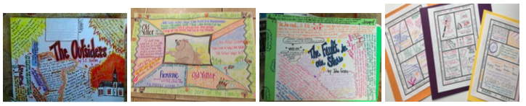

Directions:
- Your One-Pager may be completed either on paper or digitally on a platform like PowerPoint. Students who complete the assignment digitally must be able to print the assignment.
- Your name should be written clearly on the assignment.
- Use the following as a checklist to complete your One-Pager:
- Pull out two or three strong quotes from the novel
- Use images that represent key events and themes in the novel
- Make a personal statement about what you have read (not a summary)
- Ask a question or two about key ideas in the novel and answer it/them
- Design your One-Pager so that someone who has never read the novel will gain an understanding of the text through your work
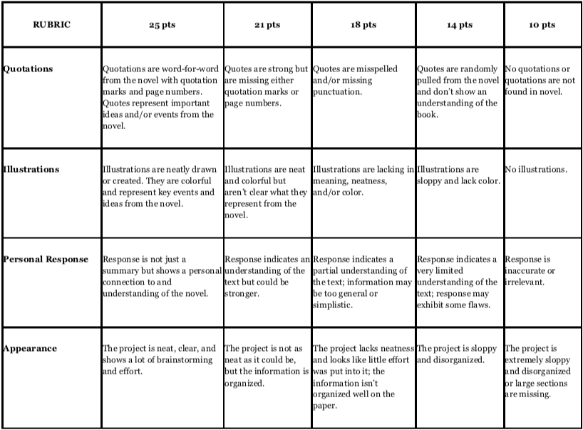

Assignment 2: Essay/Writing Prompt Response
Every student will choose ONE writing prompt for ONE novel to write an essay. Written responses should contain the student’s name at the top. Responses should be four to five paragraphs in length, and each paragraph should be five to eight sentences in length. Your responses should cite several pieces of evidence from the novel to support your thinking. All essays are graded as final drafts with the TNReady writing rubrics (linked at the end of this document).
Writing Prompts for 6th grade, A Monster Calls
- In A Monster Calls, Conor becomes more and more isolated, and his classmates leave him alone when they see that he's not doing well. How does isolation make things worse for Conor and people in general? What would you do if you were Conor's friend? (Graded with explanatory rubric)
- Truth and storytelling are important ideas in A Monster Calls. Explain the meaning behind the three tales the monster tells Conor. Why did the monster tell Conor these stories? (Graded with explanatory rubric)
Writing Prompts for 6th grade, The Mysterious Benedict Society
- Mr. Curtain uses subliminal messages for evil, and Mr. Benedict believes he can use them to reverse the panic (for good). Can subliminal messages realistically be used for good, or only for evil? Write an essay arguing the merits or detriments of subliminal messages. (Graded with argument rubric)
- The kids in the story are all “gifted” in different ways. Are there different ways to be smart? What are they? Is there one type of smart that is better than others? Write an informative essay describing ways that people can be smart. (Graded with argument rubric)
Writing prompts for 7th Grade, Warriors Don’t Cry
- Who supports Melba in her quest for fair treatment? Identify three individuals who aided Melba and briefly describe how they supported Melba (Graded with explanatory rubric).
- Melba makes great sacrifices to oppose injustice. What are the costs? Use details from Warriors Don’t Cry to explain what Melba gives up in her efforts (Graded with explanatory rubric).
Writing prompts for 7th Grade, Ghost
- The cover of Ghost includes this question: “Running for his life, or from it?” Explain the role that running plays in Ghost’s life. Why does he start running? How does his reason for running change? How is he running for his life? How is he running from his life? (Graded with explanatory rubric)
- What leads to Ghost’s decision to steal a pair of running shoes? Why does he feel like stealing is his only option? What are the short- and long-term consequences of his decision? What lesson does he learn as a result? (Graded with explanatory rubric)
Writing prompts for 8th Grade, The Hate U Give
- Analyze how Starr's experience of witnessing Khalil's death changes her view of her relationship with Chris. What is the author's purpose for including this shift in Starr's worldview? (Graded with explanatory rubric)
- Discuss the importance of speaking up in the novel. In what ways does Starr grow when it comes to learning to use her voice to fight for the issues she is passionate about? How does the author use this to create Starr’s dynamic character? (Graded with explanatory rubric)
Writing prompt for 8th Grade, One Crazy Summer
- Discuss how Delphine's perspective of her racial identity changes over the course of the novel. (Graded with explanatory rubric)
- What are Delphine's sources of information about what a mother should and should not be? How do these expectations shape Delphine's relationship with her mother? (Graded with explanatory rubric)
LINK to Argument rubric
Link to Explanatory rubric
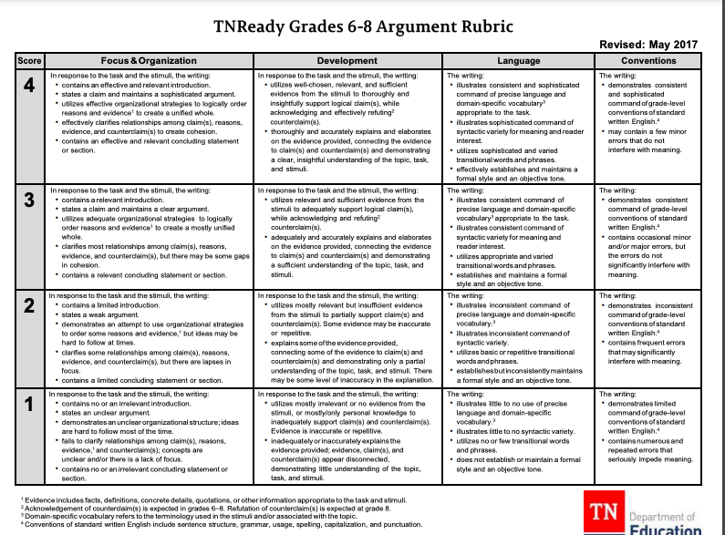
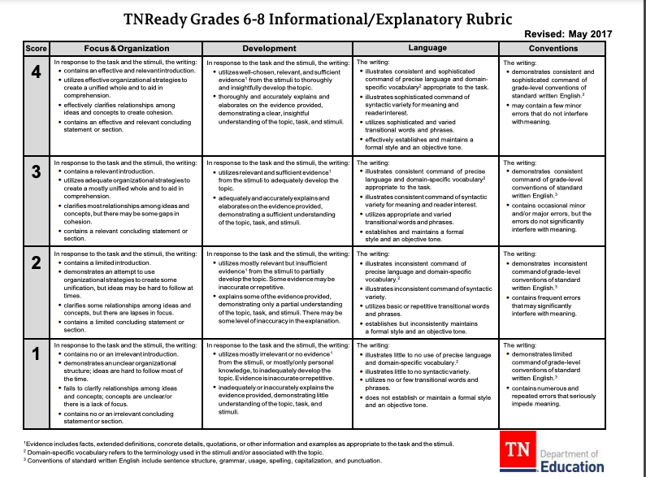

SEE BELOW FOR MATH ASSIGNMENTS

Maxine Smith STEAM Academy

Summer Math 2022

6th Grade Directions:

Complete the following unit from eMATHinstruction. You are expected to complete all lessons in the assigned unit. Each lesson has a video to watch, and a PDF file attached. You will watch the video for each lesson. The first two pages of the PDF file go along with the video. The second two pages are the practice from the lesson that you will need to complete and submit to your teacher when we return to school. You can complete work on notebook paper or print the documents and complete work on the printed copies. The work is due the first Friday of school. You are expected to complete all required lessons with at least 80% accuracy to receive full credit. The assignments will count as a project grade for the first quarter of school.

6th Grade Math Summer Work:

- https://www.emathinstruction.com/courses/n-gen-math-6/
- Unit 1 – complete ALL lessons
- Unit 2 – recommended but not required

7th Grade Directions:

As part of our MSSA Optional program, students are expected to exceed all district requirements. For the summer, students are expected to complete the following lessons by the first Friday of school. The assignments are self-paced, have a teaching video, and worksheets. Students MUST watch all videos to answer the questions on the worksheets. The work is due the first Friday of school. You are expected to complete all required lessons with at least 80% accuracy to receive full credit. The assignments will count as a project grade for the first quarter of school.

7th Grade Math Summer Work:

- https://www.emathinstruction.com/courses/n-gen-math-6/unit-7-ratios-and-rates/
- Unit 7: Ratios and Rates – complete ALL lessons
- https://www.emathinstruction.com/courses/n-gen-math-7/unit-3-proportional-relationships/
- Unit 3: Proportional Relationships – complete ALL lessons

8th Grade Directions:

As part of our MSSA Optional program, students are expected to exceed all district requirements. For the summer, students are expected to complete the following lessons by the first Friday of school. The assignments are self-paced, have a teaching video, and worksheets. Students MUST watch all videos to answer the questions on the worksheets. The work is due the first Friday of school. You are expected to complete all required lessons with at least 80% accuracy to receive full credit. The assignments will count as a project grade for the first quarter of school.

8th Grade Math Summer Work:

- https://www.emathinstruction.com/courses/n-gen-math-8/unit-7-exponents-and-roots/
- Unit 7: Exponents and Roots – complete ALL lessons
- https://www.emathinstruction.com/courses/n-gen-math-8/unit-10-scientific-notation/
- Unit 10: Scientific Notation – complete ALL lessons

Algebra 1 Summer Work:

Complete the following units from the 8th grade curriculum at emathinstruction.com. Each lesson has a video to watch and a pdf file attached. You will watch the video for each lesson. The first 2 pages of the pdf file go along with the video. The second 2 pages include the practice problems from the lesson that you will need to complete and submit when we return to school. Packets of all the practice problems were distributed the last week of school. If you did not receive your packet, they will be available for pick up from the main office at East High School. The work is due the second Friday of next school year. You should have majority of summer work complete when school starts but will also have the first 2 weeks of school to finish the work. You are expected to complete all required lessons with at least 80% accuracy to receive full credit. I am available to assist during summer through email. Thanks.

-Mr. Davis
davisc7@scsk12.org

https://www.emathinstruction.com/courses/n-gen-math-8/

Unit 1: Lessons 1-8
Unit 5: Lessons 1-10
Unit 6cc: Lessons 1-6
Unit 7: Lessons 1-8

